Recognized pattern: Aples_variety1

The form of the pattern:

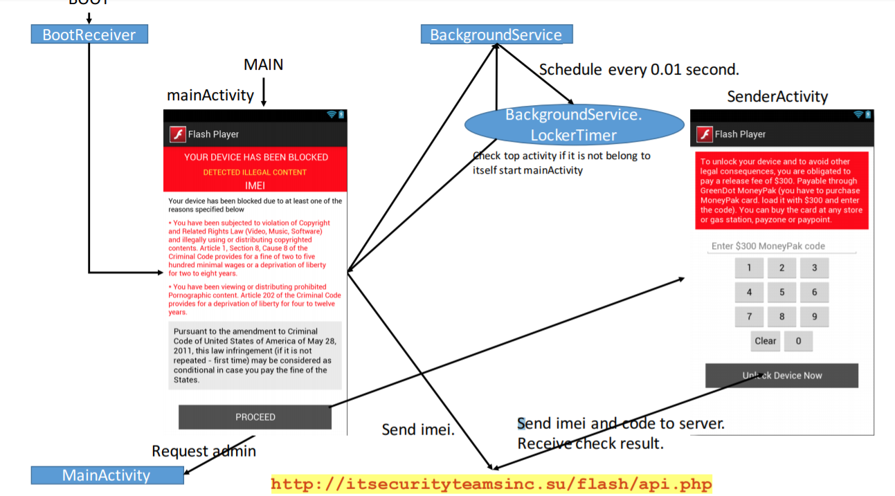

Name of Sample app:

Flash Player

The name of this app:

Delta Chat

For functional modules:

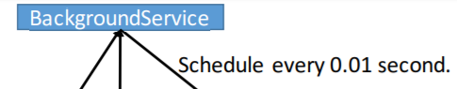

Corresponding to the key code in sample app:

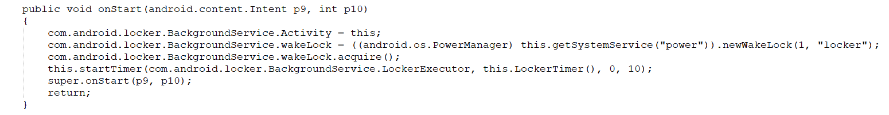

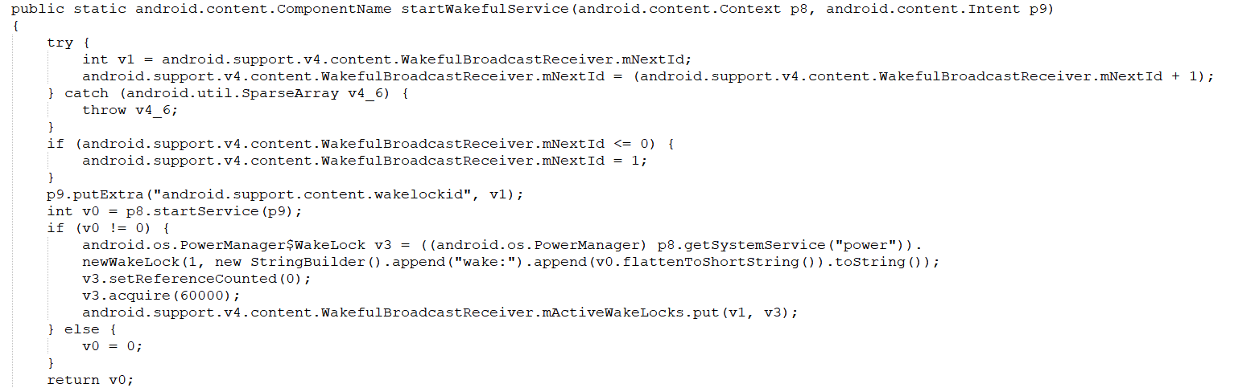

Corresponding to the key code in this app:

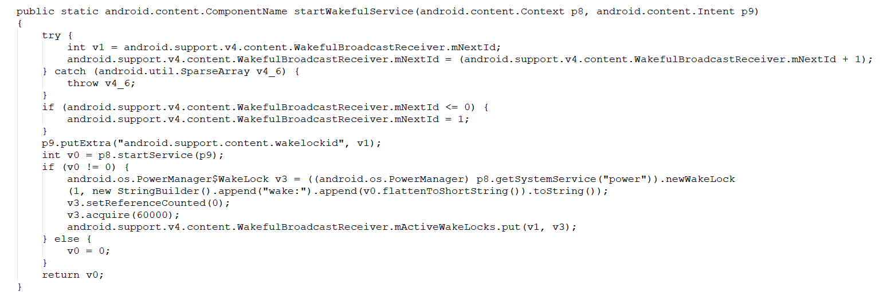

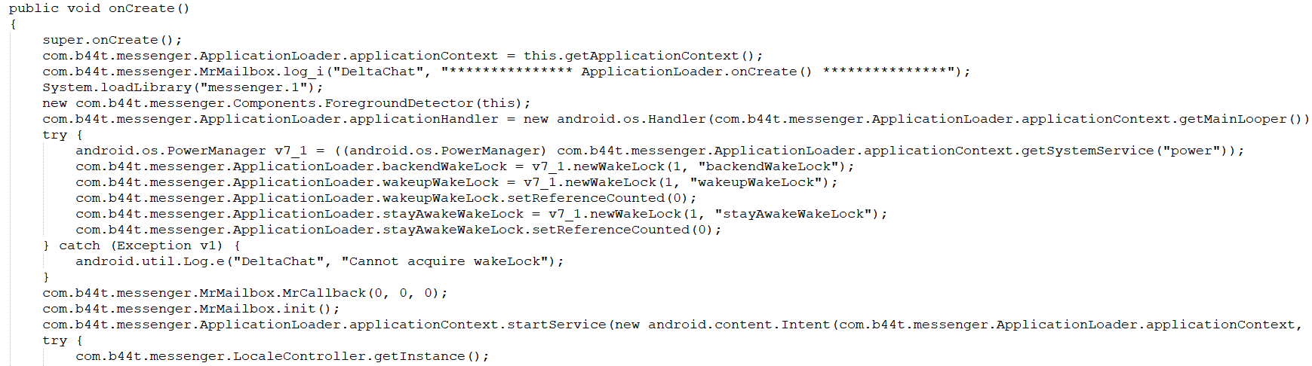

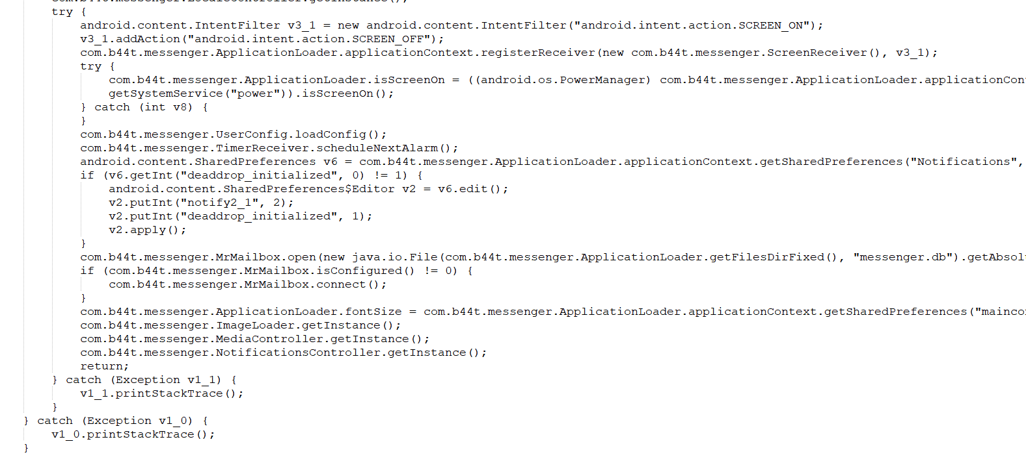

For functional modules (access to personal information):

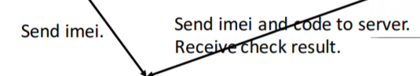

Corresponding to the key code in sample app:

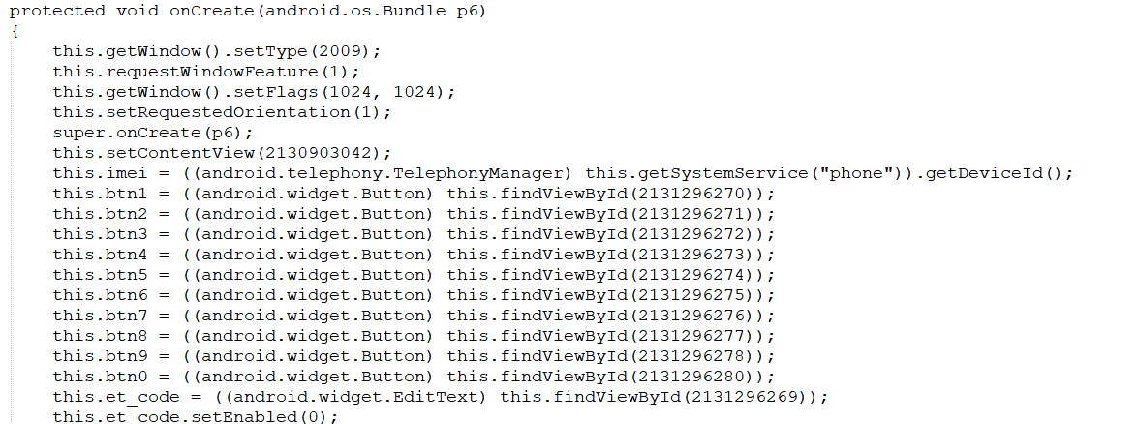

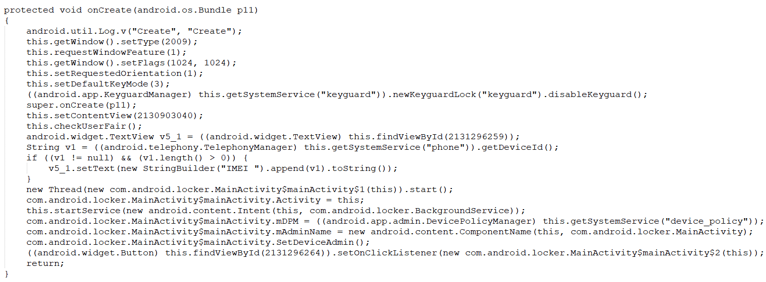

Corresponding to the key code in this app:

